Ifremer
Snanny-OwncloudApi
Architecture document

Arnaud THOREL
12/01/2016

Abstract
The present document describes snanny-owncloudapi detailed architecture

Generalities
The snanny-owncloudapi is an owncloud plugin that allow to retrieve metadata about observations and systems. This plugin give:
- Access to restful API describes in this document.
- Detailed informations to owncloud end-user

Observations and systems are stored in different kind of files:
- SensorML file: Description file which contains properties for an observation system, SensorML can be used to describe a wide range of sensors, including both dynamic and stationary platforms and both in-situ and remote sensors.
- O&M file : Description file which contains metadata for an observation

Project structure
Snanny-owncloudApi plugin respect owncloud guidelines in project organization, and separate responsibilities
Folder | Description
appinfo | Description files of the plugin, database schemas and routing rules
controller | Controllers which provides rest services
css | Stylesheets used by the plugin
db | Data access objets to query the database and domain object
hooks | Event listeners :  - File added  - File deleted  - File modified  - File shared  - File unshared
img | Images used by the plugin
js | Frontend scripts used by the plugin to show informations to the end-user
parser | Parser of O&M files and SensorML files

Database
This chapter describes the database schema used by the plugin, there are two types of tables:
- Owncloud tables used in read mode only
- Plugin specific tables used in read/write mode.

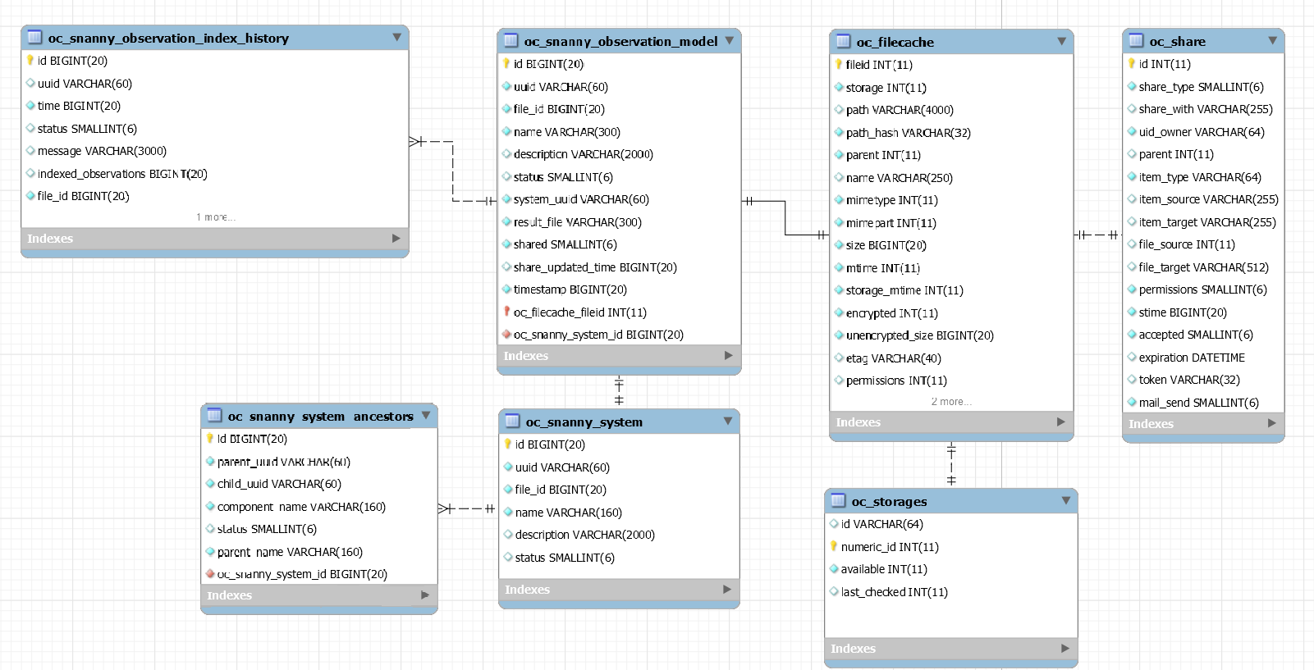
  - Snanny_observation_model

Description: Metadata of an O&M file
Column | Type - Size | Options | Description
id | INT(11) | primary | Technical identifier autoincrémented
file_id | INT(11) | not null | Internal id of the file in owncloud
uuid | VARCHAR(60) | unique | Unique identifier of the observation
name | VARCHAR(300) | not null | Name of the observation
description | VARCHAR(2000) |  | Description of the observation
system_uuid | VARCHAR(60) | not null | Unique identifier of the system used to capture observation
result_file | VARCHAR(300) | not null | Observation file name
timestamp | INT(11) | not null | Last updated time of the file
status | SMALLINT(6) |  | Status of the file (1:EXIST, 0:DELETED)
shared | SMALLINT(6) |  | Shared status of O&M file (1:SHARE, 0:NOT_SHARE)
share_updated_time | INT(11) |  | Last updated time of the shared status

  - Snanny_system

Description: metadata of a SensorML file
Column | Type - Size | Options | Description
id | INT(11) | primary | Technical identifier autoincrémented
file_id | INT(11) | not null | Internal id of the file in owncloud
uuid | VARCHAR(60) | unique | Unique identifier of the system
name | VARCHAR(300) | not null | Name of the system
description | VARCHAR(2000) |  | Description of the system
status | SMALLINT(6) |  | Status of the file (1:EXIST, 0:DELETED)

  - Snanny_system_ancestors

Description: system hierarchy
Column | Type - Size | Options | Description
id | INT(11) | primary | Technical identifier autoincrémented
parent_uuid | INT(11) | not null | Unique identifier of the parent system
parent_name | VARCHAR(300) | not null | Name of the parent system
child_uuid | VARCHAR(60) | unique | Unique identifier of the child system
component_name | VARCHAR(300) | not null | Name of the child system
status | SMALLINT(6) |  | Status of the system (1:EXIST, 0:DELETED)

  - Snanny_observation_index_history

Description: indexation result of an observation kept in history
Column | Type - Size | Options | Description
id | INT(11) | primary | Technical identifier autoincrémented
time | INT(11) | not null | Date of the indexation
status | SMALLINT(6) | not null | Status of the indexation (1:SUCCEED, 0:FAIL)
indexed_observations | INT(11) |  | Number of items extracted from observation file
message | VARCHAR(300) |  | Indexation message
file_id | INT(11) | not null | Internal id of the file in owncloud
uuid | VARCHAR(60) | not null | Unique identifier of the observation

  - Filecache, storages, share

Description: Owncloud table that store metadata of files and share options.

Hooks
Hooks are used to execute code before or after an event has occurred. This is for instance useful to run cleanup code after users, groups or files have been deleted.
The snanny-owncloudApi registered hooks:
Hook | Description
File:postCreate | Raised after the creation of a file in owncloud, this hook is used to parse file (if is SensorML or O&M) in aim to extract metadata.  Theses metadata will be stored in tables oc_snanny_observation_model, oc_snanny_system and oc_snanny_system_ancestors
File:postUpdate | Raised after the modification of a file in owncloud, this hook is used to parse file (if is SensorML or O&M) in aim to extract metadata.  Theses metadata will be updated in tables oc_snanny_observation_model, oc_snanny_system and oc_snanny_system_ancestors
File:preDelete | Raised after the modification of a file in owncloud, this hook is used to change the status of an existing observation or system.  That allow to store existence information of the element, this information will allow to give feedback to user which try to get metadata about O&M or SML
Share:post_hare | Raised after the creation of a share entry of a document  If the document is an O&M file, the fields shared and shae_updated_time are modified
Share:post_unshare | Raised after the deletion of a share by end-user or by routines if share has expiration date. If the document is an O&M file, the fields shared and shae_updated_time are modified
Files:loadAdditionalScripts | Hook that allow to add scripts and styles when user browse folder in aim to add metadata informations stored by the plugin

Rest services
The plugin provides rest full services, part of these services is public with no required permissions, and another part is used to index data and are secured by authentication.

Public API

Path | Method | Description
/sml/{uuid} | GET | Return the content file of the sensorML describe by the uuid  Params :  Uuid : unique identifier of a sensorML
/sml/{uuid}/download | GET | Automatically download file of the SensorML describe by the uuid  Params :  Uuid : unique identifier of a sensorML
/sml/{uuid}/info | GET | Retrieve informations of the SensorML describe by the uuid  Params :  Uuid : unique identifier of a sensorML
/om/{uuid}/info | GET | Retrieve informations of the Observation model describe by the uuid  Params :  Uuid : unique identifier of an observation

